Capstone Project 1: Final

Appliances Energy Prediction –

Business Problem Description – Dataset contains the house temperature and humidity conditions were monitored with a ZigBee wireless sensor network. As per the description on UCI website, each wireless node transmitted the temperature and humidity conditions around 3.3 min, then, the wireless data was averaged for 10 minutes periods. The energy data was logged every 10 minutes with m-bus energy meters. Combining this data with the weather data based on the date time columns

Link for the Jupyter file - https://github.com/arijitsinha80/Springboard/blob/master/Project/Capstoneproject_Phase2_Final.ipynb

Link for PPT –
https://github.com/arijitsinha80/Springboard_CapstoneProject1/blob/master/Capstone%20Project%201_Final.pptx

Dataset Details –
We have two data sets - energydata_complete.csv and CrudeOilPrice.csv. We have
taken two different dataset to get better prediction with analyzing the engorge consumed and how was the fuel price during the particular date.
We do not have any missing values in energydata_complete.csv; it has 19735 observation with 29 attributes pertaining to temperature, humidity, light, wind speed, dew, and visibility from local weather channel.

We do not have any missing value in CrudeOilPrice.csv, which has the fuel price for respective months and dates. This dataset has 2519 observation and 2 attributes of date and fuel price.
Few Key observation are as below –

- The dataset is from 2016-01-11 and 2016-05-27; have data starting JAN to MAY of 2016.
- These are the temperature reading captured inside and outside the house. From the explored reading of each sensor is between 14.89 and 29.85 but ‘T6’ is between -6 and 28.29. The possible reason can be its reading are for outside.
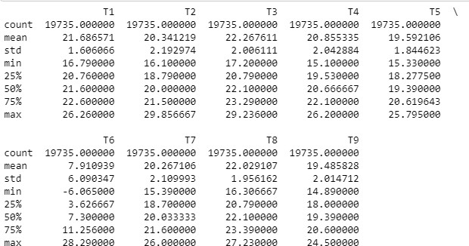
- There are Humidity related information as well in the dataset, from the explored reading of each sensor is between 20.46 to 58.79 but ‘RH_5’ and ‘RH_6’ has max of 96.32 and 99.9.
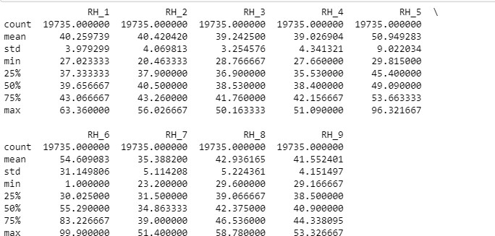

- The max value is 1080wh, whereas 75% of usage is under 100wh. Some of the appliances has high consumption. These can be outliers but, currently keeping them as part of the dataset and not dropping them from the dataset.

- If we see the statistics for Appliance Attributes, the minimum value is 10 and max value is 1080, and the mean is 97.69 and 75% of records are below 100 KWH. This column has outliers and we will keep them and check during our modeling.
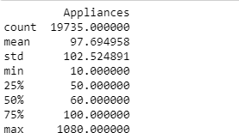

When merging the two datasets, in energydata dataset, date is a timestamp and
in crudeoilprice dataset, date is a date datatype, so we have to normalize the date, in order for us to merge the two datasets.

1. After the merge, we observe that “ values" columns is merged on the dataset, but it doesn’t have all the dates values and 5904 records has null values.
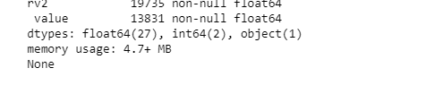

To solve these null values, we used the “forward fill” method and value column was populated with previous day values for the records, which were null and renamed the column to "oilprice".
The total number of observation is 19735 and 30 Attributes.

From the Data Wrangling activity, we created the input.csv as the final dataset. This has 19735 observations and 30 attributes.

Divide the data in dimension wise to explore from the input dataset –

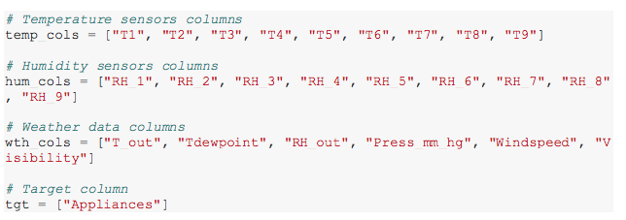

From the above dimensions, we will start to explore data for each – Plot the scatter matrix for Temperature attributes using method “ diagonal="kde"

Plot the scatter matrix for Temperature attributes using method “ diagonal="kde"
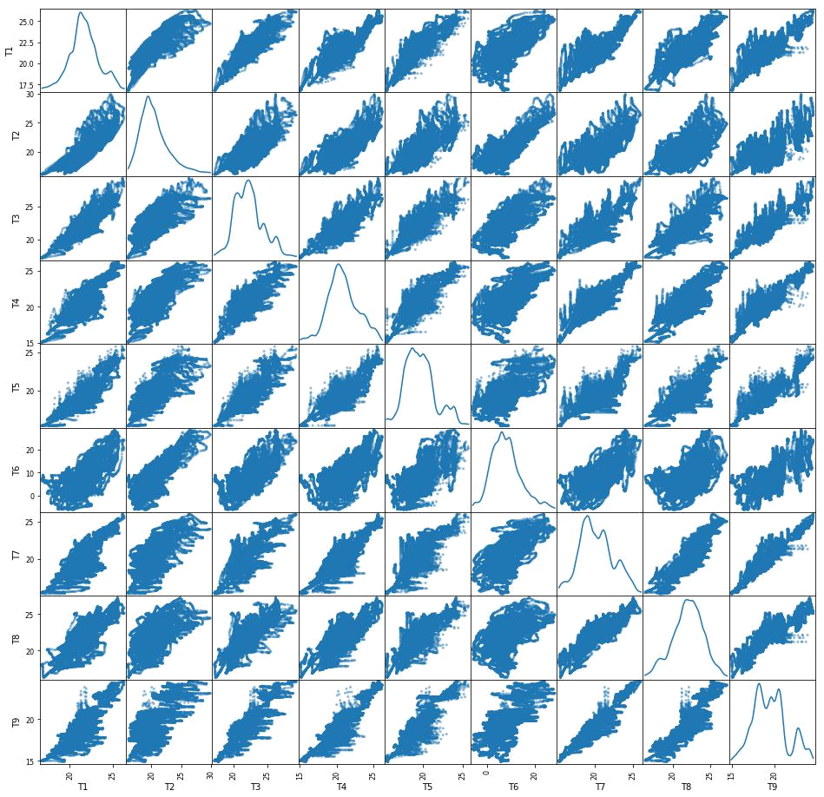

- From the above figure, we can see that there is some linear relation between T7 and T9. Others are having the shape but are not exactly linear.

- There is a relation between these two attributes but also have some outliers
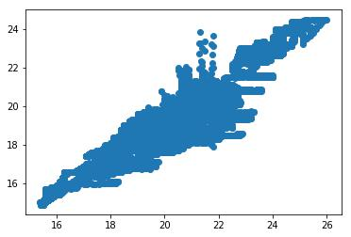

T6 and T_out is highly correlated, T6 is from the outside the house reading and T_out is the data collected from weather's site
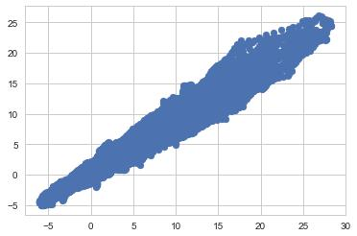

Explore the data using the Weather Dimension -
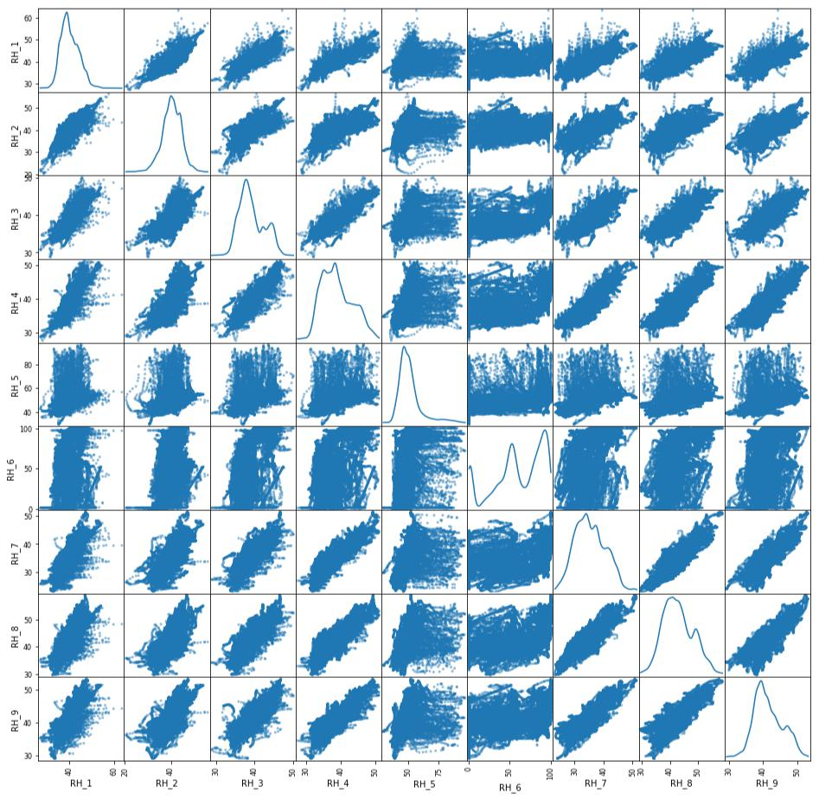

- There doesn’t seems to be having any linearity between any of the attributes.

Lets explore the distribution using the histogram –
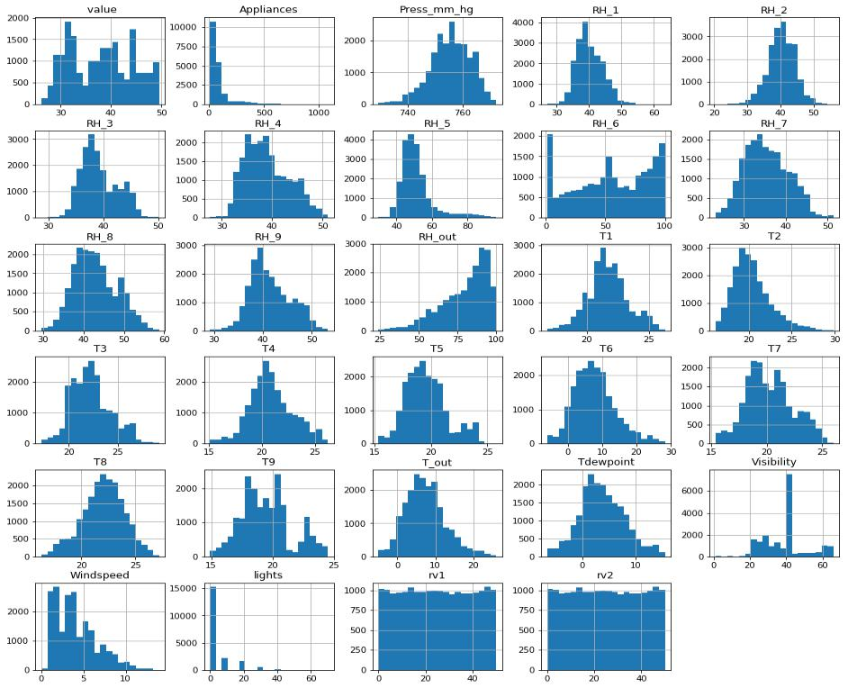

- All humidity values are almost having normal distribution except RH_6 and RH_out. In other words the reading from inside the home is having normal distribution.

- All temperature readings follow a Normal distribution except for T9.

- Visibility, Windspeed and Appliances are having skewed data.

- Rv1 and Rv2 are random variables and doesn’t seems to be contributing

On the Target Attribute – Appliance, the below histograms is rightly skewed and most of the data is with 200 KWh.
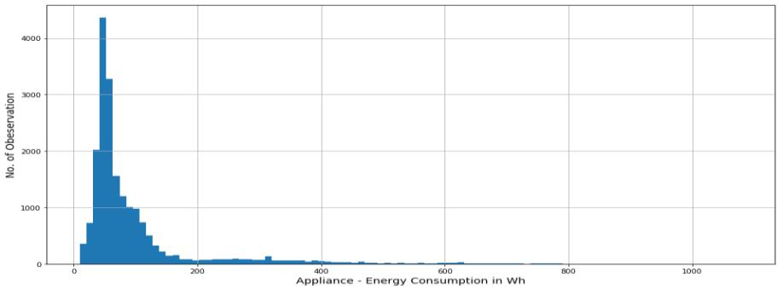
Target variable, Appliances is highly right skewed.
Alternatively exploring using Boxplot – on Appliance Attribute
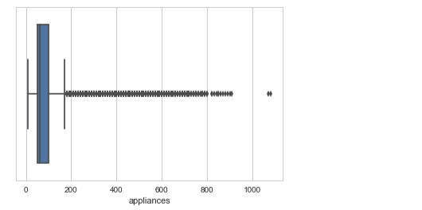

- Percentage of dataset in range of 0-200 KWh is 90.291%

Using the date attributes, created new columns for Month and Weeks using the datetimestamp method

With taking the average on week – Monday the usage has been higher, followed by Saturday and Friday.
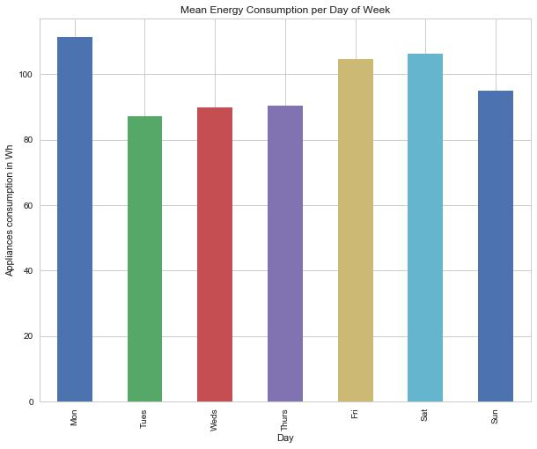

For Monthly Average – On a average, February and April the consumption has been more than other months.
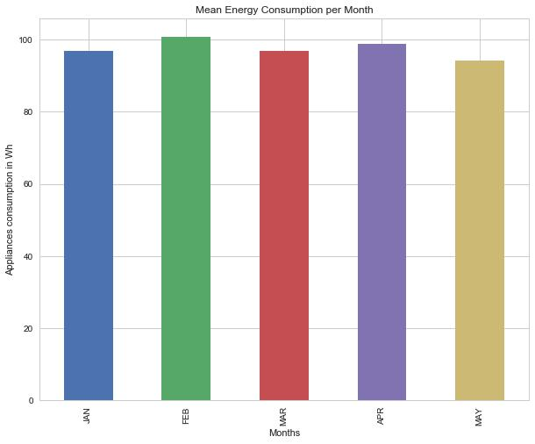

For Day wise consumption – plotting this date wise, energy consumption, In January month there were 2 days when the consumption was more than 1000 KWh.
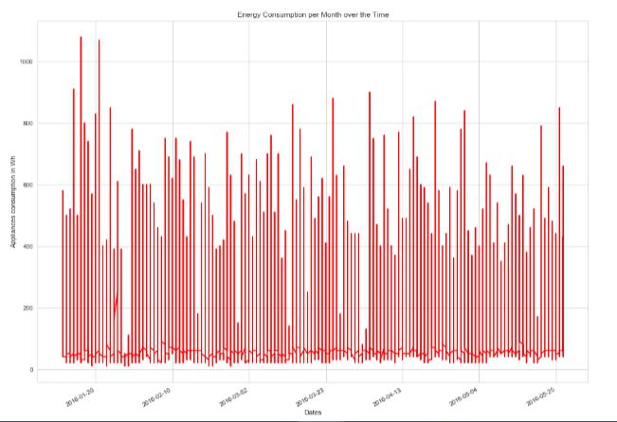

Since the Appliance data captured were rightly skewed, converting the column to Log values to see if it has the normal distribution.
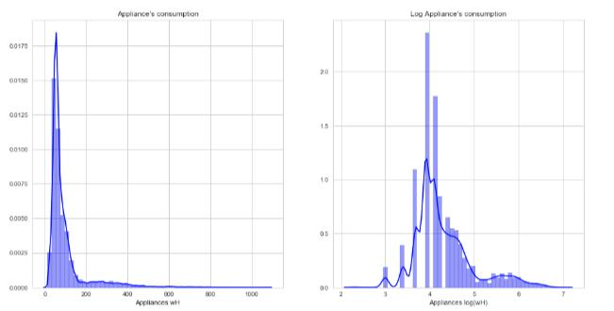

Let’s explore the Correlation plot –

With Appliance attribute –
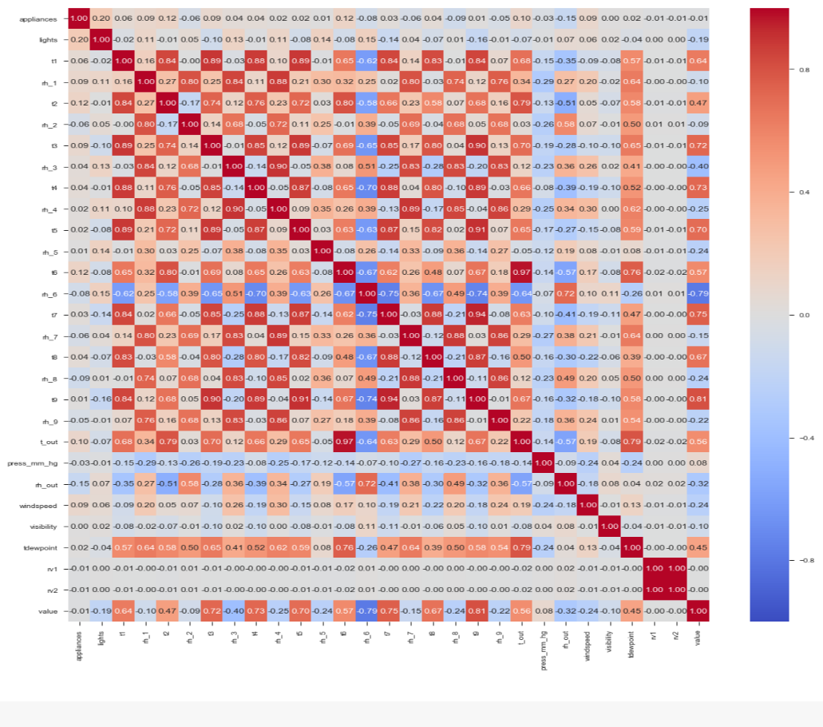
Scatterplot between appliances and t2
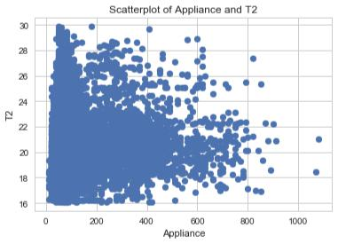

Scatter plot between Appliance and Lights
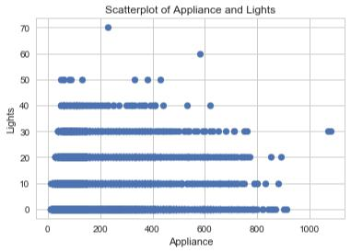

Scatterplot between Appliance and T6
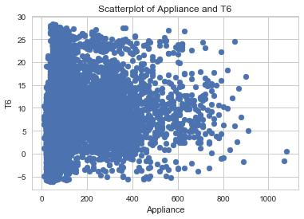
Scatterplot between Appliance and T_out
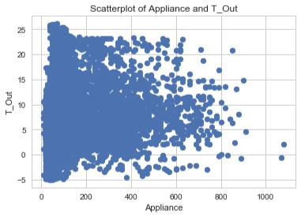

Correlation plot of using Log value of Appliance -
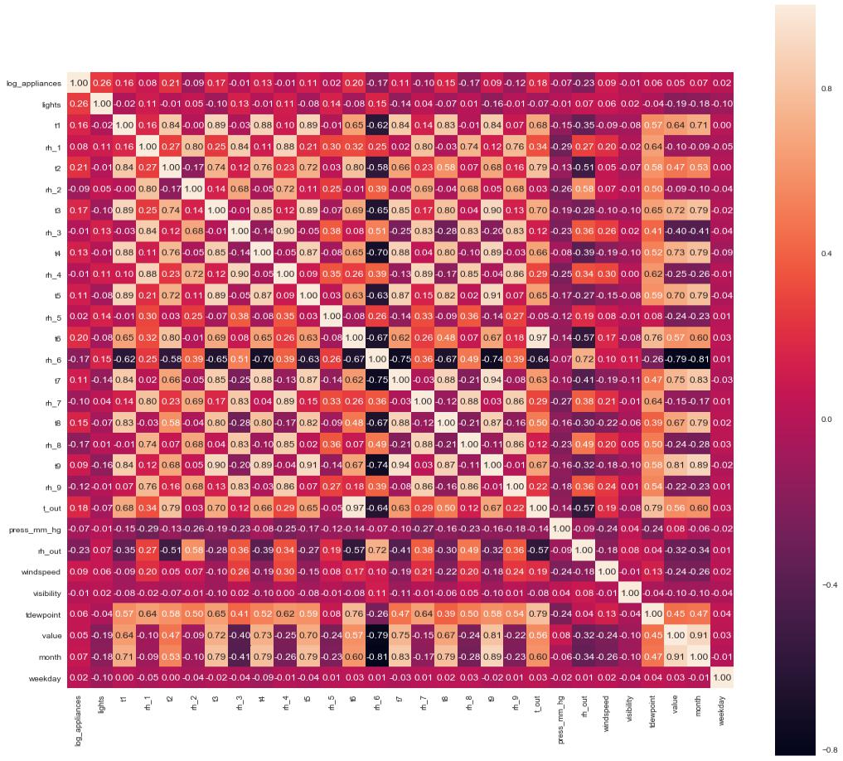
With Log Appliance

- The most correlated features with energy consumption(log_appliances) are: lights=0.26, t6=0.20, t2=0.22, t3 = 0.17,t_out = 0.18, rh_out = -0.23, rh_8 = -0.17, rh_6 = -0.17, windspeed = 0.09.

- In a linear regression problem only linear independent variables can be be used as features to explain energy consumption otherwise we will have multicollinearity issues.

Scatter plot of log_appliance and t1
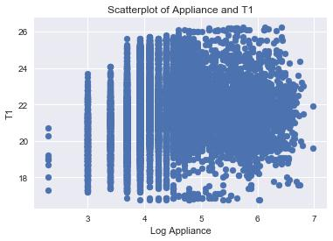

Scatterplot between log_appliance and lights
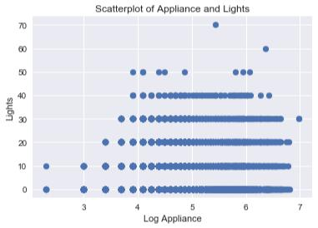

Scatter plot between log appliance and t_out

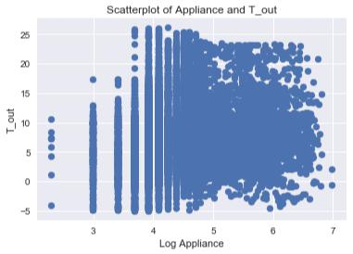

Variables that are particularly significant in terms of predicting Appliance Energy Consumption based on the correlation matrix –

- Between Appliance and Lights

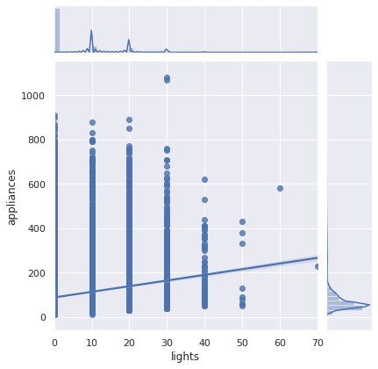

- Between Appliance and Windspeed

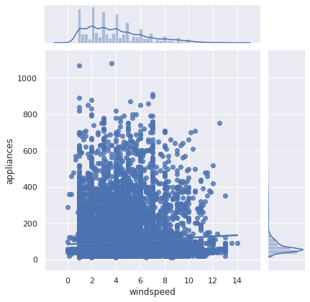

- Between Appliance and T6

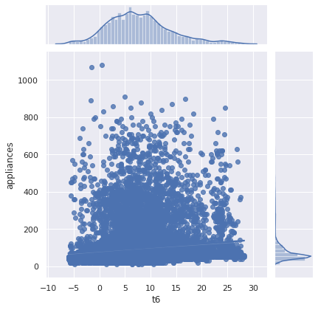

- Between Appliance and T2

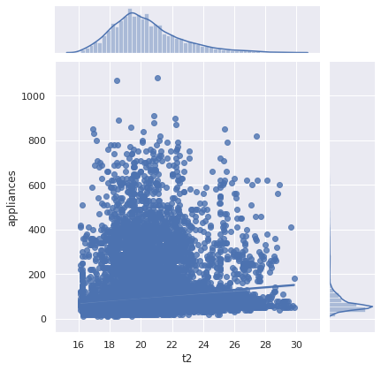
- Between Appliance and T3
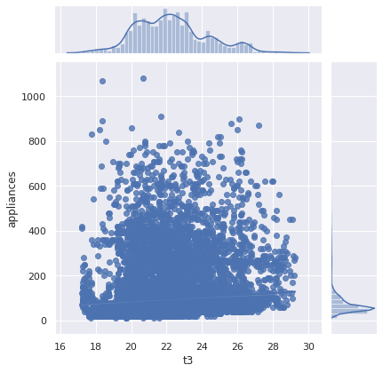

Calculate the Correlation between Temperature features -

- Correlation between T9 and T1 pearson 0.84 0.00 None
- Correlation between T9 and T2 pearson 0.68 0.00 None
- Correlation between T9 and T3 pearson 0.90 0.00 None
- Correlation between T9 and T4 pearson 0.89 0.00 None
- Correlation between T9 and T5 pearson 0.91 0.00 None
- Correlation between T9 and T6 pearson 0.67 0.00 None
- Correlation between T9 and T7 pearson 0.94 0.00 None
- Correlation between T9 and T8 pearson 0.87 0.00 None

Check, if the Temperature, Humidity and Weather features influences Appliance –

1. Coefficient table (middle table). We can interpret the t3 coefficient (4.3471) by first noticing that the p-value (under P>|t|) is so small, basically zero. This means that the t3 is a statisticall significant predictor of appliance energy consumption.
The regression coefficient for t3 of 4.3471 means that on average, each additional t3 temperature is associated with an increase the appliance energy consumption
The confidence interval gives us a range of plausible values for this average change, about (3.637 and 5.058)
R^2 is only 0.007, hence t3 doesn't contribute much on the variance. F-Statistic The F-Statistic is 143.8 and the probability for this statistic is 5.09e-33, which is close to 0. We can safely reject the null hypothesis, indicating that at least one 𝛽 coefficient is nonzero.
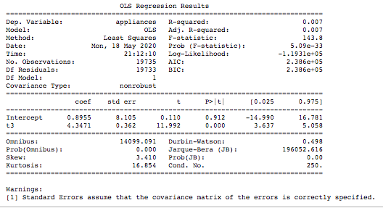

2. Coefficient table (middle table). We can interpret the t3+t6 coefficient (0.4119, 1.8871) by first noticing that the p-value (under P>|t|) is so small, basically zero. This means that the t6 is a statisticall significant predictor of appliance energy consumption.
The regression coefficient for t6 of 1.8871, means that on average, each additional t6 temperature is associated with an increase the appliance energy consumption
The confidence interval gives us a range of plausible values for this average change, about (1.566 and 2.208)
R^2 is only 0.014, hence t3 and t6 doesn't contribute much on the variance. F-Statistic The F-Statistic is 138.8 and the probability for this statistic is 1.39e-60, which is close to 0. We can safely reject the null hypothesis, indicating that at least one 𝛽 coefficient is nonzero.
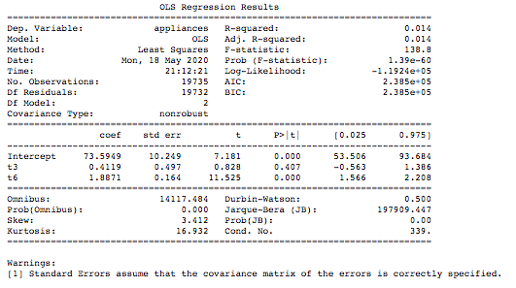

3. Coefficient table (middle table). We can interpret the t3+t6+rh_out coefficient (1.8057, 0.3079, -0.9076) by first noticing that the p-value (under P>|t|) is so small, basically zero. This means that the t6 is a statistical significant predictor of appliance energy consumption.
The regression coefficient for rh_out of -0.9076, means that on average, each additional t6 temperature is associated with an decrease the appliance energy consumption
The confidence interval gives us a range of plausible values for this average change, about (-1.025 and -0.790)
R^2 is only 0.025 better than previous, hence t3, t6 and rh_out doesn't contribute much on the variance. F-Statistic The F-Statistic is 170.3 and the probability for this statistic is 4.96e-109, which is close to 0. We can safely reject the null hypothesis, indicating that at least one 𝛽 coefficient is nonzero.
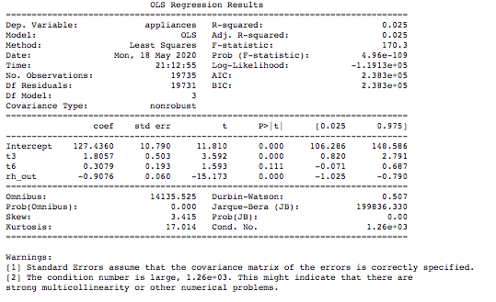
4. Coefficient table (middle table). We can interpret the t1+t2+t3+t4+t5+t6+t7+t8+rh_1+rh_2+windspeed, coefficient (9.0446, -25.6614, 17.7293,-1.4768,-7.3830,-7.5650,1.0356,-6.2685,9.4475,20.0347,-20.3286,1.6784) by first noticing that the p-value (under P>|t|) is so small, basically zero. This means that the t6 is a statisticall significant predictor of appliance energy consumption.
The confidence interval of t3 gives us a range of plausible values for this average change, about (15.814 and 19.644)
R^2 is only 0.098 better than previous, F-Statistic The F-Statistic is 194.5 and the probability for this statistic is 0. We can safely reject the null hypothesis, indicating that at least one 𝛽 coefficient is nonzero.
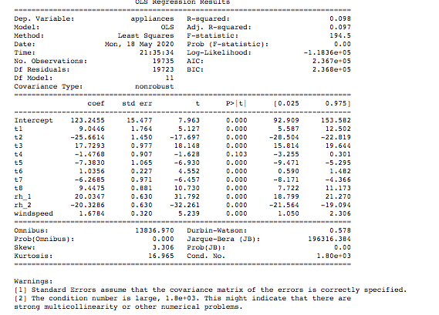
Pairplot for 't6','t2', 'rh_2','lights','t_out','windspeed','tdewpoint' features for their distribution –
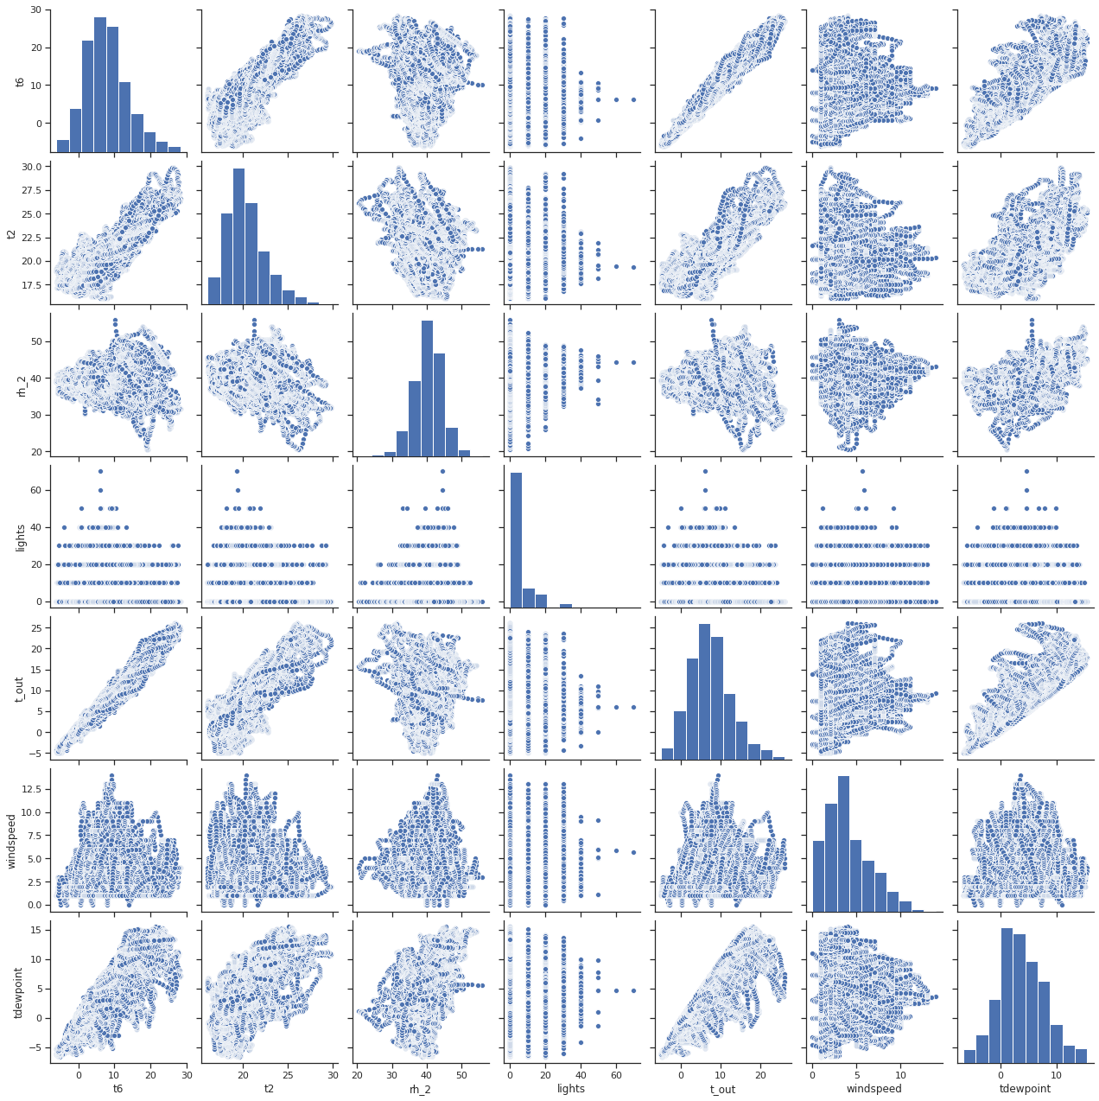

Is there a significant difference between T6 and T_out and impact my future Prediction Models

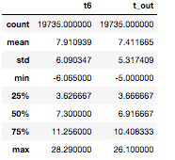
With Description and plotting the jointplot of the two features -
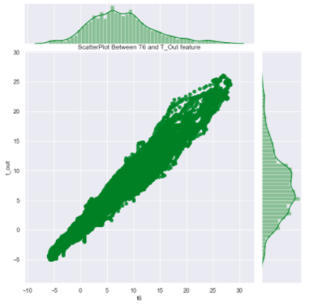

It seems like there is linear relation between 'T6' and T_out'

To find the Correlation between all the Features and Target – Appliances -

 | Correlation coefficients | p-value
appliances | 1.000000 | 0.000000e+00
lights | 0.197278 | 2.305108e-172
t2 | 0.120073 | 2.784947e-64
t6 | 0.117638 | 9.333867e-62
t_out | 0.099155 | 2.624854e-44
windspeed | 0.087122 | 1.456471e-34
rh_1 | 0.086031 | 9.639431e-34
weekday_avg | 0.085900 | 1.208067e-33
t3 | 0.085060 | 5.086416e-33
t1 | 0.055447 | 6.449169e-15
house_temp | 0.054740 | 1.411780e-14
t4 | 0.040281 | 1.507881e-08
t8 | 0.039572 | 2.683103e-08
rh_3 | 0.036292 | 3.402540e-07
t7 | 0.025801 | 2.890302e-04
t5 | 0.019760 | 5.503451e-03
rh_4 | 0.016965 | 1.715603e-02
tdewpoint | 0.015353 | 3.102113e-02
t9 | 0.010010 | 1.596635e-01
rh_5 | 0.006955 | 3.286027e-01
weekday | 0.003060 | 6.672580e-01
visibility | 0.000230 | 9.741858e-01
week | -0.011356 | 1.106606e-01
month | -0.011606 | 1.030264e-01
value | -0.013535 | 5.725207e-02
house_hum | -0.020075 | 4.799007e-03
press_mm_hg | -0.034885 | 9.493922e-07
rh_9 | -0.051462 | 4.697109e-13
rh_7 | -0.055642 | 5.187296e-15
rh_2 | -0.060465 | 1.873022e-17
rh_6 | -0.083178 | 1.209481e-31
rh_8 | -0.094039 | 5.211566e-40
rh_out | -0.152282 | 1.077516e-102

Create a New DataFrame to conducting T-Statistics and Changing it to Categorical column –

- Create the dataframe with “lights” and “appliances”.
- Update the feature where the number of lights are 40 or more as 1
- Update the feature where the number of lights are 39 or less as 0
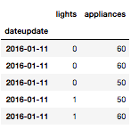
- When conducted the T-test , T-Statistics is 133.85 and pvalue is 0, hence we can reject the null hypothesis and conclude that there is a statically significant difference.

Major Inference –
- Temperature feature from T1-T9 and T_out have positive correlation with the target Appliances. For the indoor temperatures, the correlations are high as expected. Four columns have a high degree of correlation with T9 & T3,T5,T7,T8 also T6 & T_Out has high correlation (both temperatures from outside) . Hence we can remove the T9 and T_out from the model in next section.
- Weather attributes - Visibility, Tdewpoint, Press_mm_hg have low correlation values
- Humidity - There are no significantly high correlation cases for humidity sensors.
- Random variables have no role to play; hence we will remove these features from the model in next section.

Model Building and Implementation –

As identified earlier – we are dropping the below field –
  - 'date_x', 'appliances','rv1', 'rv2','t6','t9' from the dataset.
  - Created the X will all the features and Y with the target feature.
  - Using train_test_split method, we have done the split of the dataset in 70% Training data and 30% test data.
  - Upon running the Linear regression model- we get the below score for R^2 and RMSE(Root Mean Square Error)
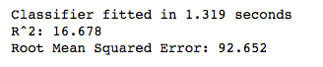
Also, with Cross validation, we didn’t see the improvement in the performance of the benchmark algorithms –
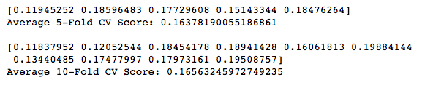
Now, we will try to scale the data and find best performing model –
  - Dropped the x_date feature from the dataset, and using the StandardScaler method, scaled the dfactual dataframe.
  - From the scaled dataset, dropped the 'appliances','rv1', 'rv2','t6','t9'.
  - Created the Training and Test Dataset with 70-30% ratio.
Create the following models with key important features –
- Regularized linear models as an improvement over Linear Regression.
  - Ridge Regression
  - Lasso Regression
- Ensemble based Tree Regression models, which deal with number of features and outlier data.
  - Random Forests
  - Gradient Boosting
  - Extra Trees
- Neural networks for non-linear relationships target feature and predictors.
  - Multi-Layer Perceptron

  - Implemented them in a iterative manner with creating different functions
    - Created function to capture the fit and predict the models and capture the score and accuracy for the models
    - Created the pipeline and passed all the algorithms to be executed in the above function.
    - Created a function to display and store the results / outcome.
    - Below is the results displaying the R^2 and RMSE and time it took to predict.
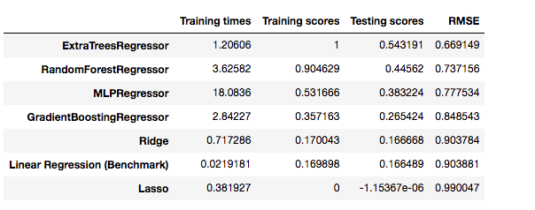

  - Comparing the Training time –

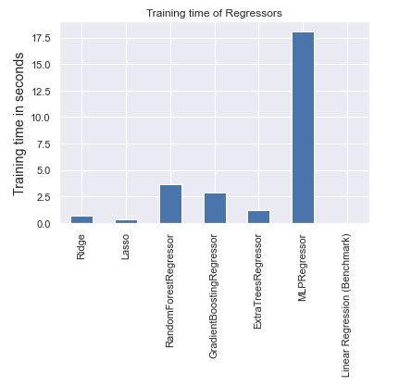
  - Plot to compare the performance of the algorithms on datasets

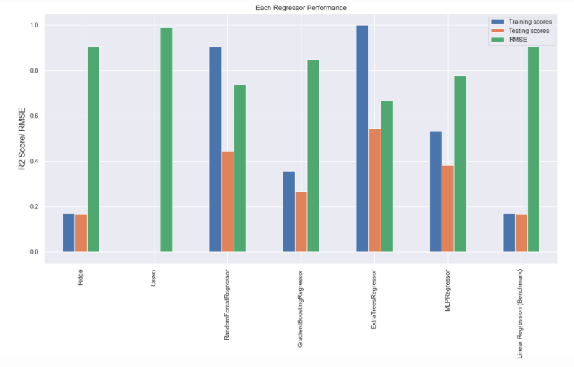

Interpretation –
Least performing Repressor - Lasso Repressor and best performing Repressor - Extra Trees Repressor. Even though Extra Trees Repressor has a R2 score of 1.0 on training set, which might suggest over-fitting but, it has the highest score on test set and also, it's RMSE value is also the lowest. Clearly, ExtraTreesRegressor is the best model out of given models.
  - Hyper-parameter tuning the best Model – “ExtraTreesRegressor” observed from above step – Using the RandomizedSearchCV, we will find the best estimators and using those estimators we will perform the prediction.

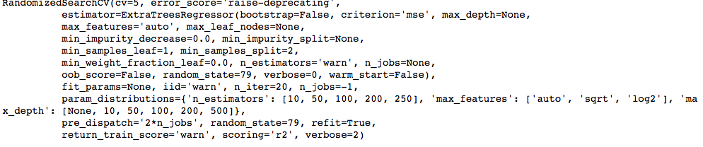

  - Using the best parameter we will fit and predict the training data and predict on test data.

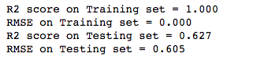

  - Plotting the data for y_test_s and predicted data –

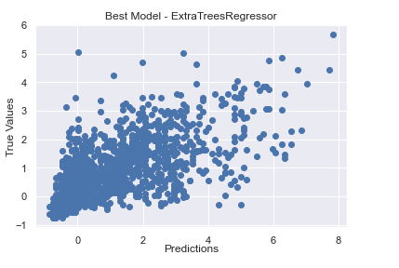
Using the seaborn plot using regplot function

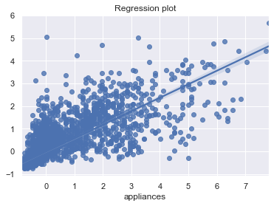

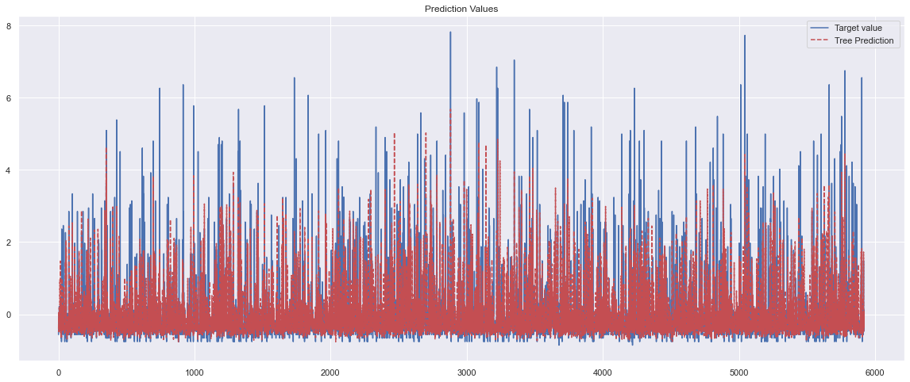
Overlaying the test data and predicted data, we can see that the prediction on not so accurate.

Interpretation from Implementation -
- R2 score improvement compared to Benchmark model = 0.463.
- RMSE improvement compared to Benchmark model = 0.301.
- R2 score improvement compared to without tuned model = 0.086.
- RMSE improvement compared to without tuned model = 0.066.

  - Important features contributing from the data set are as below –

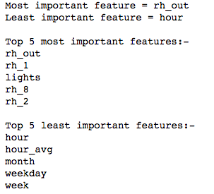

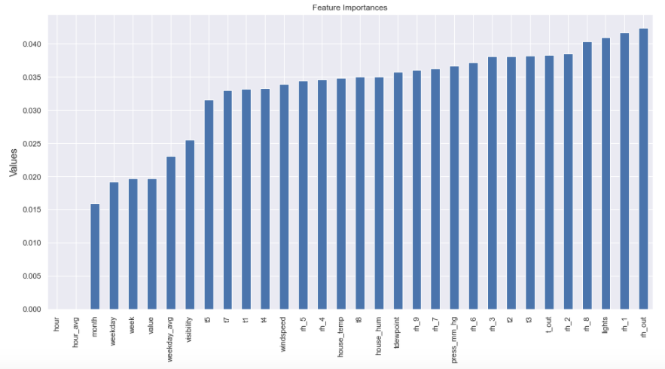
Feature and Model Evaluation-

      - Clone the above best model clone with the 'rh_out', 'rh_1', 'lights', 'rh_8', 'rh_2', 't_out', 't3', 't2' and do a prediction only with the most important feature, to verify if there is any improvement in the model accuracy.
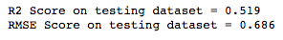
      - Comparing these results with above best performing algorithms – Extratreeregressor
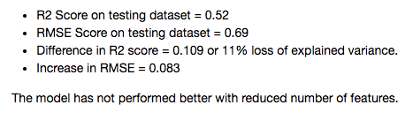
Conclusion -
- Best Algorithm is ExtraTreesRegressor.
- Top 5 most important features:- rh_out, rh_1, lights, rh_8, rh_2
- Variance explained on test set = 63%.
- RMSE error = 60.3%

- R2 score improvement compared to Benchmark model = 0.463.
- RMSE improvement compared to Benchmark model = 0.301.
- R2 score improvement compared to without tuned model = 0.086.
- RMSE improvement compared to without tuned model = 0.066.

